Lesson Plans March 23rd - March 27th *Links to Specials are at the bottom of the Lesson Plans
Subject | Monday | Tuesday | Wednesday | Thursday | Friday
Math On | 1.Q3:8 Daily Spiral Review (optional)  2.Watch Khan Academy Video customary units of length  3.Complete iReady Lesson- “Practice- Convert Customary Units of Length”  Due Friday | 1. Q3:8 Daily Spiral Review (optional)  2.Watch Khan Academy Video customary units of weight  3.Complete iReady Lesson- “Practice- Convert Customary Units of Weight”  Due Friday | 1.Q3:8 Daily Spiral Review (optional)  2.Watch Khan Academy Video customary units of liquid volume  3.Complete iReady Lesson- “Practice- Convert Customary Units of Liquid Volume ”  Due Friday | 1.Q3:8 Daily Spiral Review (optional)  2.Watch Khan Academy Conversion Word Problem Examples  3.Complete “Measurement Conversion Practice”  Due Friday- Graded Assignment | 1.SELF GRADE Daily Spiral Review Q3:8 using answer key page- correct mistakes (optional)  2.Watch Khan Academy Conversion Word Problem Examples  3.Complete “Measurement Conversion Practice”  Due Friday- Graded Assignment- Post to Seesaw or email to teacher
Math Adv | Multiplying Decimals  1.Daily Spiral-Monday (optional/extra practice)  2. Watch Khan Academy video:  Intro to Multi. Decimals  3. Complete IReady lesson “ Multiply Decimals”  Due by Friday | Multiplying Decimals  1.Daily Spiral-Tuesday (optional/extra practice)  2. Watch Khan Academy video:  Multiplying Decimals  3. Complete IReady lesson “ Multiply Decimals”  Due by Friday  4. Click the link below, post your answer on the message board.  Oh No, What's Wrong? | Dividing Decimals  1.Daily Spiral-Wednesday (optional/extra practice)  2. Watch Khan Academy lessons.  Dividing Decimals  3. Complete IReady lesson “ Divide Decimals”  Due by Friday | Dividing Decimals  1.Daily Spiral-Thursday (optional/extra practice)  2. Watch Khan Academy lessons.  Dividing Decimals to .100  3. Complete IReady lesson “ Practice Dividing Decimals”  Due by Friday | Multiplying/ Dividing Decimals  1.Daily Spiral-Self Check (optional/extra practice)  2. Watch Khan Academy review lessons.  Multi/Div decimals  3. Complete the following problems..pdf is also in the resource folder titled Multi/Div Problems  graded assignment  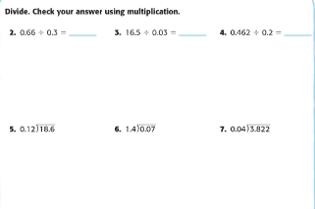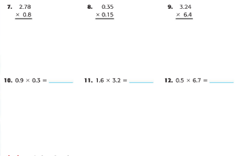
Math Acc  All acc math assignments due by Friday 3/27 | ACC Q3:8 Daily Spiral Review found in resource folder (optional)  1.Watch Kahn Academy video Interpreting Relationships in Ordered Pairs  2.Complete Kahn Academy practice Tables from Rules that relate two variables  (a variable is a number in this case) | ACC Q3:8 Daily Spiral Review (optional)  1.Complete Khan Academy Practice Rules that relate 2 variables  (a variable is a number in this case)  2.Complete “Function Machines-Creating Equations” found in resource folder SELF GRADE using attached answer key | ACC Q3:8 Daily Spiral Review (optional)  1.Watch Khan Academy Video Graphing Sequence Relationships  2. Complete “Graph Patterns Reteach Worksheet” found in resource folder  3. Upload to SeeSaw Accelerated Math folder (Math5Stockard) | ACC Q3:8 Daily Spiral Review (optional)  TAG DAY- no new assignment | SELF GRADE Daily Spiral Review Q3:8 using answer key page- correct mistakes (optional)  1.Complete “5OA3 graded assignment” found in resource folder  2.Upload completed assignment to SeeSaw Accelerated Math folder (Math5Stockard) graded assignment
Reading  *Graded  Homework:  Read 20-30 mins.  each night | I-Ready assigned lesson:  Determine Word Meanings Using Context Clues  Optional Activities for the week:  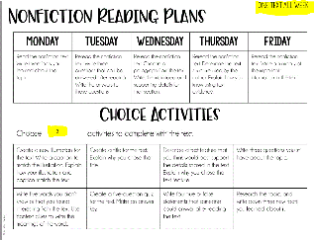  Optional activities can be submitted on Teams, SeeSaw or by email whatever is easier for your child. | I-Ready assigned lesson:  Comparing Story Topics and Themes  Optional Activities for the week:  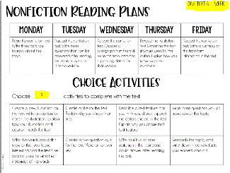  Optional activities can be submitted on Teams, SeeSaw or by email whatever is easier for your child. | I-Ready assigned lesson:  Comparing Patterns of Events in Stories  Optional Activities for the week:  Optional activities can be submitted on Teams, SeeSaw or by email whatever is easier for your child. | I-Ready assigned lesson:  Comparing Points of View  Optional Activities for the week:  Optional activities can be submitted on Teams, SeeSaw or by email whatever is easier for your child. | I-Ready assigned lesson:  Explaining an Author’s Reasons and Evidence  Optional Activities for the week:  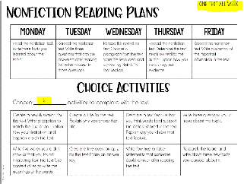  Optional activities can be submitted on Teams, SeeSaw or by email whatever is easier for your child.
Writing  *Writing resources can be found in resources folder or on Ms. Hunt’s website at: huntfourth.weebly.com | 1.Read through the “Power Words” PowerPoint, noticing how powerful words can be used to help us get a point across. Pay close attention to how the author elaborates on their opinion using Power Words.  2.Complete the “Your Turn” slide in the PowerPoint on “Power words worksheet.” Elaborate on a second reason why schools should include P.E. classes using Power Words. Use “Power Words Chart.” Print worksheet or answer on separate sheet of paper and upload to Seesaw or email to your teacher for feedback! | 1.Read through the “Power Words” PowerPoint, noticing how powerful words can be used to help us get a point across. Pay close attention to how the author elaborates on their opinion using Power Words.  2.Complete the “Your Turn” slide in the PowerPoint on “Power words worksheet.” Elaborate on a second reason why schools should include P.E. classes using Power Words. Use “Power Words Chart.” Print worksheet or answer on separate sheet of paper and upload to Seesaw or email to your teacher for feedback! | 1. Read through the “Power Words” PowerPoint, noticing how powerful words can be used to help us get a point across. Pay close attention to how the author elaborates on their opinion by using Power Words.  2. Follow the directions on the “On Your Own” slide of the PowerPoint. Write 2-3 paragraphs about an activity that you believe should be a part of every school day. You can type this or write it on a sheet of paper. Use power words!  3. Use “Power Words Rubric” to check your work.  4. Post to Seesaw or email to your teacher. Grade will be recorded  (Due Next Friday 4/3) | 1. Read through the “Power Words” PowerPoint, noticing how powerful words can be used to help us get a point across. Pay close attention to how the author elaborates on their opinion by using Power Words.  2. Follow the directions on the “On Your Own” slide of the PowerPoint. Write 2-3 paragraphs about an activity that you believe should be a part of every school day. You can type this or write it on a sheet of paper. Use power words!  3. Use “Power Words Rubric” to check your work.  4. Post to Seesaw or email to your teacher. Grade will be recorded  (Due Next Friday 4/3) | 1. Read through the “Power Words” PowerPoint, noticing how powerful words can be used to help us get a point across. Pay close attention to how the author elaborates on their opinion by using Power Words.  2. Follow the directions on the “On Your Own” slide of the PowerPoint. Write 2-3 paragraphs about an activity that you believe should be a part of every school day. You can type this or write it on a sheet of paper. Use power words!  3. Use “Power Words Rubric” to check your work.  4. Post to Seesaw or email to your teacher. Grade will be recorded  (Due Next Friday 4/3)
Social  Studies/  Science  All Social Studies assignments due Friday 3/27 | Continue “Fakebook” project using rubric and weeks 23- 24 in Studies Weekly: due Friday, 3/27 | Reread week 23 in studies weekly | Complete week 23 test in studies weekly (you may go back to look for answers in the newspaper) graded assignment 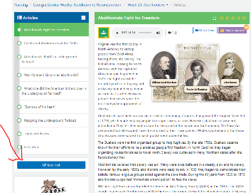 | Reread week 24 in studies weekly | “Fakebook” project due today  Complete week 24 test in studies weekly (you may go back to look for answers in the newspaper) graded assignment  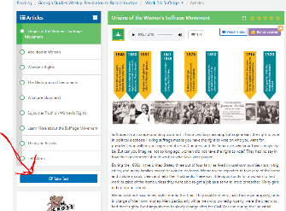

Supplemental Resources: These are not Fulton County sites.

https://www.khanacademy.org/ (Khan Academy videos assist with math skills)
https://app.studiesweekly.com/online/ (Studies Weekly newspaper for Social Studies and Science)

Special Lessons for the week:

Art: http://hfespecials.weebly.com/4th-grade-lessons1.html

Music with Trude: http://hfespecials.weebly.com/4th-grade-lessons-trude.html

Music with Wallace: http://hfespecials.weebly.com/ms-wallaces-classes.html

PE: http://hfespecials.weebly.com/4th-grade-lessons2.html

Spanish: http://hfespecials.weebly.com/4th-grade-lessons.html

